2019 CASE Advancement Internship Program
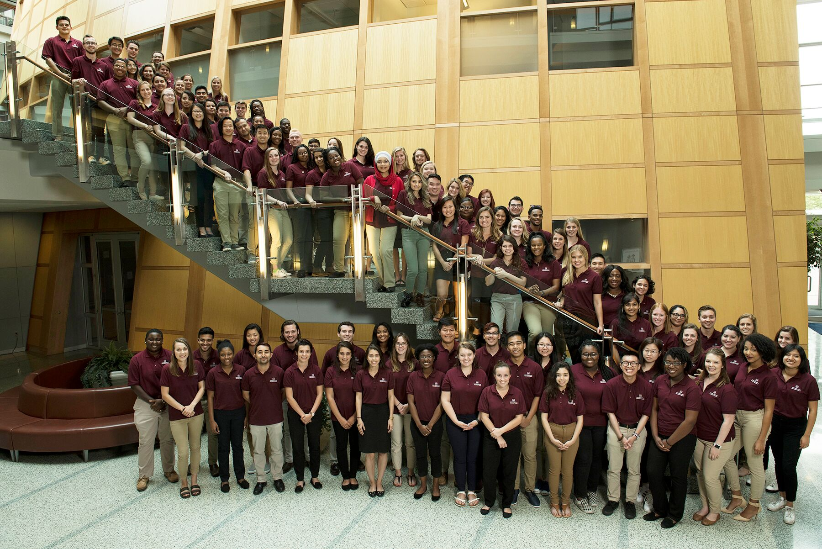
Explore a career in higher education advancement this summer and get paid!
The CASE Advancement Internship program seeks to increase and diversify the number of professionals in educational advancement. This program is designed to attract students (undergraduate and graduate) who may not have previously considered a career in institutional advancement. Internships run from June 3 – July 26, 2019.
Host Institution: Insert Name
Internship Description
Insert Description

Stipend
Insert Stipend Amount or Hourly Wage

CASE Benefits
In addition to receiving a paid stipend, CASE Advancement Interns receive a number of professional development benefits designed to assist students in exploring a career in advancement while networking with professionals in the industry. Benefits include:
- Three day CASE Advancement Internship Conference in Washington, DC (June 30 – July 2, 2019)
- Participation in introductory CASE advancement webinars
- A book allowance from the CASE Bookstore
- Mentor from your institution
- Participation in CASE’s e-Mentoring program to network with an advancement professional outside your institution
- CASE student membership for one year after the internship, accessing complimentary CASE webinars, the CASE library and Career Central
- Regular communication post-internship on entry-level job postings and career development opportunities

Eligibility Criteria and Application Requirements
- Applicants must be an undergraduate, graduate student or a recent graduate within six months of the internship start date.
- An updated resume
- Two letters of recommendation, signed and on letterhead
- A statement purpose and commitment to diversity: In a statement of up to 750 words, please share your interest in educational advancement, how the internship program would future your interest, and the importance of diversity within the workplace.
Please click here to complete the online application form.
Application must be completed by February 8, 2019 to be considered. No applications will be accepted after this deadline. In the application, you will have the opportunity to select //Institution// as one of your top 5 host institutions for CASE to send your online application materials.
For additional information download the CASE Advancement Internship FAQ or contact Robyn Neeley at 202.478.5632 or neeley@case.org.
About CASE: The Council for Advancement and Support of Education (CASE) is a professional association serving educational institutions and the advancement professionals who work on their behalf in alumni relations, communications, development, marketing and allied areas. CASE helps its members build stronger relationships with their alumni and donors, raise funds for campus projects, produce recruitment materials, market their institutions to prospective students, diversify the profession, and foster public support of education.

