**Guidelines for sponsors and exhibitors**

**Please read the information below carefully. It is meant to provide you with all details needed to your attendance at the conference.**

REGISTERING DELEGATES FROM YOUR COMPANY

This year, **the companies are responsible for registering** their delegates for the conference.

*Attention: Booking sponsorship and exhibition items should be requested using the booking forms in this page* [*https://www.case.org/conferences-training/case-europe-annual-conference-2023/sponsorship-opportunities*](https://www.case.org/conferences-training/case-europe-annual-conference-2023/sponsorship-opportunities) *. These instructions below are solely for the purpose of delegate registration.*

**How to register a delegate from your company**

* Go to the registration page of the conference: <https://www.case.org/conferences-training/case-europe-annual-conference-2023/registration>
* Click on “registration”
* If you don’t have an account, you can create one. You will need to go back to CEAC registration page after that
* Follow the registration pages, answering all the questions
* You will have the option to register for the specific tracks (newcomers’ and leadership) and for the gala dinner in one of the steps (these have separate costs)
* In the payment page there is a box “add coupon or promo code”
* Please include **SPONSOR24** in this box
* That should change the cost of delegate passes to zero
* Please note the number of delegate passes that each level has as benefit (unless buying extra passes):
  + GOLD: 04
  + SILVER: 03
  + BRONZE: 02
  + EXHIBITOR: 02

If you would like to book additional delegate passes, you can find the specific booking form here: [case.org/ceac-sponsorship](https://www.case.org/conferences-training/case-europe-annual-conference-2023/sponsorship-opportunities)

Please remember the deadline for delegate registration: **15th July**

**PLEASE NOTE:** Tickets for the gala dinner (evening of Thursday 31st August) are sold separately. Tickets cost £60pp and should be purchased in advance (see step by step above).

If you have any issues with registering your delegates, please contact Cristina Marochi - [cmarochi@case.org](mailto:cmarochi@case.org)

LIST OF DELEGATES

You will receive 3 lists of delegates prior to the event: one on the **18th July, 3rd August and 22nd August**.

EXHIBITION HALL TIMINGS

On Tuesday 29th, the exhibition hall will open to the public at 11am.

On the other days, it will be open from 8am until 6pm (except on Wednesday 30th when the Exhibitors’ Reception takes place in the hall until 7pm).

Please note that the breakfast roundtables on Wednesday 30th are from 8.30-9.15 am and on the Thursday 31st they are from 8-8.45am. Not all delegates take part of the breakfast roundtables, so if you are not taking part of the roundtables, it is up to you to be at your booth at that time or not. The main programme starts at 9.30am on Wednesday and 9am on Thursday.

You will see details about timings for logistic in another topic below.

DEADLINES

***Please make sure to have all information needed by each deadline before sending it to CASE.***

**ALL INFORMATION REQUESTED BELOW SHOULD BE SENT TO** [**CMAROCHI@CASE.ORG**](mailto:CMAROCHI@CASE.ORG)

For **GOLD** level sponsors

|  |  |  |
| --- | --- | --- |
| Deadline | item | Info required |
| 15 July | Company logo | * in jpg or png; one with transparent background |
| Company info for app | * website * Twitter, Instagram, LinkedIn handles * Text about the company (max 150 words) |
| Nameboard for stand | * name to be displayed in your nameboard |
| Session details | * session name * session description (max 250 words) * speaker(s) name(s), job title(s) and institution(s) * speaker(s) headshot(s) |
| Register company’s delegates (4) | * register company’s delegates for the conference at the CASE website |
| 4 Aug | Presentation file | * if you are using a presentation in your session, please send it to us by this deadline |

Please note that depending on the item you are sponsoring within your Gold level package, there is the benefit of distributing or placing company materials or goodies in the session room. These materials are the company’s responsibility and should be delivered to CASE staff no later than Tuesday 29th morning.

For **SILVER** level sponsors

|  |  |  |
| --- | --- | --- |
| Deadline | item | Info required |
| 15 July | Company logo | * in jpg or png; one with transparent background |
| Company info for app | * website * Twitter, Instagram, LinkedIn handles * Text about the company (max 150 words) |
| Nameboard for stand | * name to be displayed in your nameboard |
| Session details | * session name * session description (max 250 words) * speaker(s) name(s), job title(s) and institution(s) * speaker(s) headshot(s) |
| Register company’s delegates (3) | * register company’s delegates for the conference at the CASE website |
| 4 Aug | Presentation file | * if you are using a presentation in your session, please send it to us by this deadline |

For **BRONZE** level sponsors

|  |  |  |
| --- | --- | --- |
| Deadline | item | Info required |
| 15 July | Company logo | * in jpg or png; one with transparent background |
| Company info for app | * website * Twitter, Instagram, LinkedIn handles * Text about the company (max 150 words) |
| Nameboard for stand | * name to be displayed in your nameboard |
| Breakfast roundtable details | * roundtable name * roundtable description (max 250 words) * speaker(s) name(s), job title(s) and institution(s) * speaker(s) headshot(s) |
| Register company’s delegates (2) | * register company’s delegates for the conference at the CASE website |

For **EXHIBITORS**

|  |  |  |
| --- | --- | --- |
| Deadline | item | Info required |
| 15 July | Company logo | * in jpg or png; one with transparent background |
| Company info for app | * website * Twitter, Instagram, LinkedIn handles * Text about the company (max 150 words) |
| Nameboard for stand | * name to be displayed in your nameboard |
| Register company’s delegates (2) | * register company’s delegates for the conference at the CASE website |

**For APP items**

Specific files formats are needed for each item and their details will be sent once the item is booked. Files to any of the app sponsorship options should be sent in to cmarochi@case.org by 15 July.

IF YOU ARE DELIVERING A SESSION AS PART OF YOUR SPONSORSHIP PACKAGE

Your session will not have a host/chair to introduce you. Delegates will arrive at the designated room and you will be in control of the time to start and finish it.

If you are using a presentation/any type of AV, please send it to CASE by the 4th Aug, but you will still need to go to the speaker preview room at the EICC (room name to be confirmed closer to the event date) on the day of your session to check if it is correctly allocated. Speakers will not be able to plug in their computers in the session room, as it is all controlled centrally by the technicians in the AV room.

IF YOU ARE DELIVERING A BREAKFAST ROUNDTABLE AS PART OF YOUR SPONSORSHIP PACKAGE

Please arrive a bit before the starting time of the breakfast roundtable (Wednesday 30th from 8.30-9.15 am and on Thursday 31st from 8h-8.45am). There will be signs in each roundtable with the titles of the sessions. Delegates can sign up in advance to the breakfast roundtable at the CASE stand (at the centre of the hall) once the conference has started, on Tuesday, but if there is space left in the roundtable, they can join in even if they haven’t signed up for it.

SIZE AND DESCRIPTION OF THE STAND

All stands have the same size – 3x3m2. They are shell scheme systems with the following specification:

* Silver Octanorm modular system
* White Foamex infill/facia panels
* White melamine faced wall panels 2500mm high, 2435mm to the underside of the ceiling beams, aluminium post and rail frames
* Fascia to each open side 300mm deep

Each stand consists of one back wall panel and two side wall panels (if the stand is in a corner, a wall could be removed, if desired).



Furniture: each stand will be furnished with a trestle table and 2 chairs.

Electrics: all stands will have 1 x 500W socket outlet + 2 LED spotlights.

MOUNTING AND DISMOUNTING TIMES FOR THE EXHIBITION HALL

Companies can start to decorate their stands on Monday 28th August, from 3pm to 6pm, or in the morning of the Tuesday 29th August, from 8am to 10.30am. The doors of the exhibition hall will be open to public at 11am on the 29th.

The stands should be put down on the Thursday 31st, between 3.30pm and 6.30pm.

CONTACT FOR EXTRA FURNITURE OR AUDIO-VISUAL HIRE

The EICC (conference venue) offers some furniture options and cleaning services for the stands.

Cameron Logistics offers several services (furniture, AV, deliveries and collections, stand changes, signage).

You can find the following forms in the page <https://www.case.org/conferences-training/case-europe-annual-conference-2023/sponsorship-opportunities>:

* EICC furniture order form.pdf
* Stand cleaning order form
* Cameron furniture and AV info.pdf
* Cameron graphic options.pdf
* Cameron custom build
* Cameron full info on extras.pdf

Please note that it is the responsibility of the exhibitor to contact these (or other) providers and hire the extra items required. Payment for those items should also be made directly with the provider.

DELIVERIES AND COLLECTIONS OF EVENT MATERIALS

**Deliveries will be accepted from the 25th of August**

All deliveries to the EICC should be clearly marked with the following label info:

Name of Event:

Date of Event:

Name of contact on site: *Sofia Fenoglio*

Stand number and location:

Edinburgh International Conference Centre

Loading Bay

Off West Approach Road

Edinburgh

EH3 8EE

Items included:

Box n.:

* Organisers and Suppliers should ensure that arrangements are made for the collection of all items from the EICC at the end of the event.
* Items can be left for **1 working day**, before being stored, charges**\*\*** will then be applied to release items***. Items left for longer than 5 working days will be disposed of.
* **\*\***Charges may be up to **£100.00 +VAT PER DAY** following the 1 working day as mentioned above.

**\*\*\***Payment will be by credit card only. The EICC will not release items to a courier unless payment has been made in full.

PROCEDURES FOR DROPPING OFF ITEMS IN THE EICC LOADING BAY

Please note that entrance to the building is via our loading bay located at the ***Off West Approach Road, Edinburg - EH3 8EE***

See map detailed below to get to the correct area:

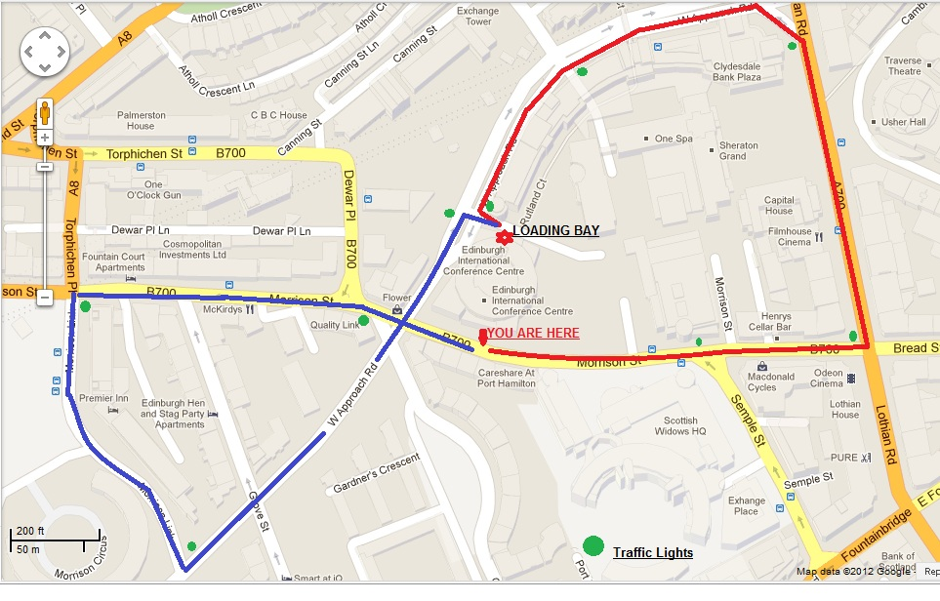

**DIRECTIONS TO THE EICC LOADING BAY**

* Heading: - EAST straight on to LOTHIAN RD. TURN LEFT. Keep in inside lane passing Sheraton Hotel TURN LEFT. Onto WESTERN APPROACH RD. Second set of lights TURN LEFT …. **LOADING BAY DOUBLE SET OF ROLLER SHUTTERS.**
* Heading: - WEST straight down MORRISON STREET. TURN LEFT onto WESTERN APPROACH LINK; TURN LEFT onto WESTERN APPROACH RD. First set of lights TURN RIGHT …. **LOADING BAY DOUBLE SET OF ROLLER SHUTTERS.**

**PARKING PROCEDURES**

Vehicles may not be left unattended in the EICC Loading Bay or parked in an unauthorised location nearby.

* This means that Organisers/Suppliers may park their vehicle and unload any necessary items into the EICC’s Loading Bay. These items will be stored safely and monitored by CCTV until the person is ready to move them within the Venue.
* As soon as the vehicle has been unloaded, it must be removed off site and parked in an appropriate place.
* Organisers may not start setting up their stand until they have removed their vehicle.

CAR PARKS NEAR THE EICC

The EICC does not have car park facilities and therefore vehicles need to park in authorized areas near the Venue. Please, find below a map showing the nearest car parks around the EICC.

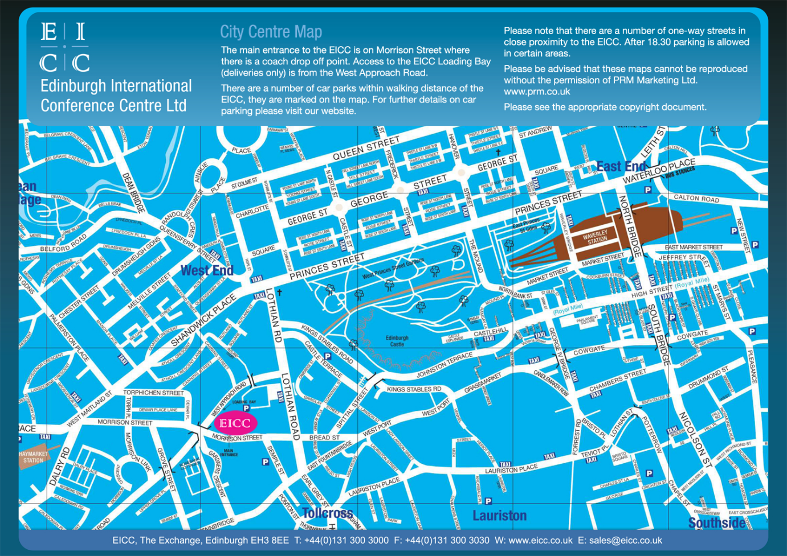

SPECIAL DEAL FOR DELEGATES OF THE EICC

Castle Terrace and EICC agreement –discount on the daily rate

* Please, note this 100% contactless and ticketless.
* Download the free NCP ParkPass App
* Register and add the SaverID: **EICC4R** to your park pass account before arriving at the car park and you must enter and exit by scanning your QR code to qualify for this discount

For any other information, please contact [cmarochi@case.org](mailto:cmarochi@case.org).