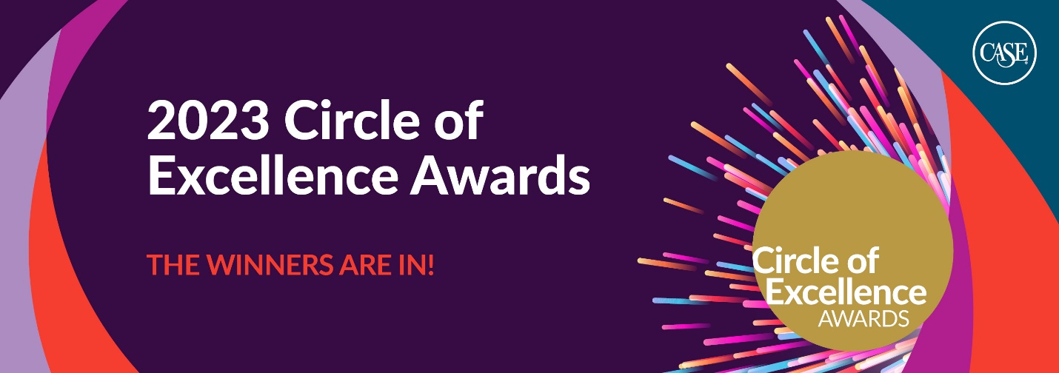

[Institution] Wins 2023 Circle of Excellence Award from the Council for Advancement and Support of Education
CASE’s awards celebrate outstanding achievements in educational advancement
June 21, 2023
Today the Council for Advancement and Support of Education announced the recipients of the 2023 Circle of Excellence Awards.
[Information about your institution and awards]
CASE’s Circle of Excellence Awards are the premier recognition program for educational advancement. These peer-selected and adjudicated awards honor colleges, universities, and schools worldwide whose talented staff have advanced their institutions with resourcefulness and ingenuity.
“The Circle of Excellence Awards showcase the impact advancement professionals have upon their institutions and communities around the globe, every day,” says CASE President and CEO Sue Cunningham. “Our 2023 honorees—from diverse institutions and teams of all sizes—are bold, creative, and resourceful. They demonstrate how powerful it is when advancement teams champion teaching, learning, research, and the progress that education ignites.”
This year volunteer judges selected 521 exemplary entries for bronze, silver, gold, or Grand Gold recognition. Winners are recognized for overall quality, innovation, use of resources, and the impact on the institution or its communities, such as alumni, parents, students, faculty, and staff.

###
About CASE:
CASE—the Council for Advancement and Support of Education—is a global, not-for-profit membership association with a vision to advance education to transform lives and society.
CASE is the home for advancement professionals, inspiring, challenging, and equipping them to act effectively and with integrity to champion the success of their institutions. CASE defines the competencies and standards for the profession of advancement, leading, and championing their dissemination and application with more than 97,000 advancement professionals at 3,100 member institutions in 80 countries.
Broad and growing communities of professionals gather under the global CASE umbrella. Currently these include alumni relations, development services, communications, fundraising, government relations, and marketing. These professionals are at all stages of their careers and may be working in universities, schools, colleges, cultural institutions, or other not-for-profits. CASE uses the intellectual capital and professional talents of a community of international volunteers to advance its work, and its membership includes many educational partners who work closely with the educational sector.
Headquartered in Washington, D.C., CASE works across all continents from its regional offices in London, Singapore, and Mexico City to achieve a seamless experience for all its stakeholders, particularly its members, volunteers, and staff.

