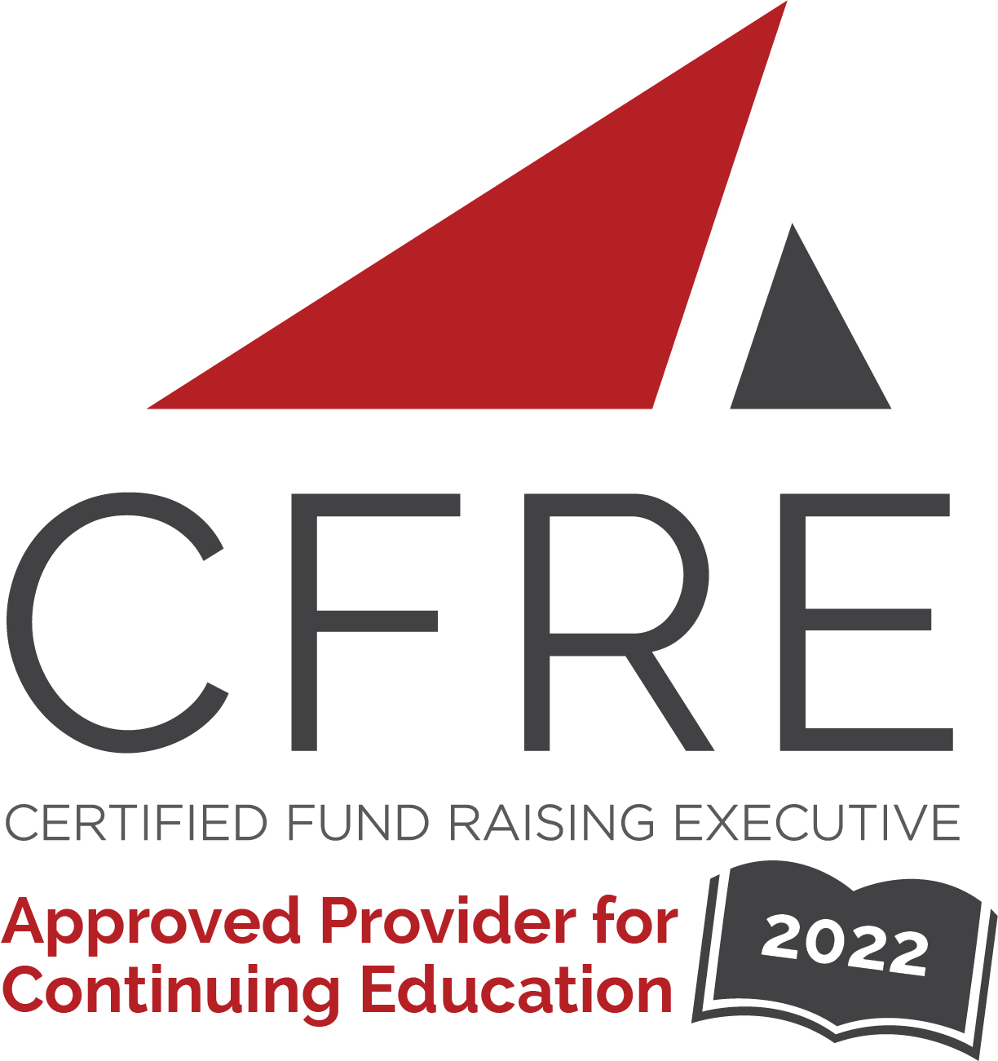  CFRE International has developed this form as a way for you to quickly track (and keep in your files!) the continuing education sessions you have attended. Simply check the boxes next to the sessions you attended. At the end of the conference, add up the total number of hours. Keep this sheet and you will be ready to complete your application form. All of the session slots listed are eligible for continuing education points on your CFRE application for initial certification and/or recertification. Sessions not listed here are not eligible for points. |  | CONTINUING EDUCATION POINTS TRACKER

Activity Organizer: - Council for Advancement and Support of Education
Title of Activity: - Homecomings and Reunions
Names of Presenter(s): - Various
Dates and Location: - 7-9 December, 2022 – Los Angeles, CA USA

Date: 7 December, 2022
Session 1: 2:00pm – 3:00pm (1 pt)
- Understanding Your Why So You Can Measure Your Success

Date: 7 December, 2022
Session 2: 3:15pm – 4:15pm (1 pt)
- Elevate and Refresh Your Homecoming and Reunion Experience

Date: 7 December, 2022
Session 3: 4:30pm – 5:30pm (1 pt)
- Ask the Experts: Making Your Experience Special

Date: 8 December, 2022
Session 4: 9:30am – 10:30am (1 pt)
- Preparing for Registration: Marketing & Communication

Date: 8 December, 2022
Session 5: 10:45am – 12:00pm (1.25 pt)
- Making the Big Splash – Signature Events, Unique Experiences and Spirit!

Date: 8 December, 2022
Session 6: 1:30pm – 2:30pm (1 pt)
- Affinity Engagement
- Professional School Engagement

Date: 8 December, 2022
Session 7: 4:30pm – 5:30pm (1 pt)
- What is the Future and How do we Reach Our Audiences

Date: 9 December, 2022
Session 8: 9:30am – 10:30am (1 pt)
- The Power of the People – Volunteer Management

Date: 9 December, 2022
Session 9: 10:45am – 12:00pm (1.25 pts)
- Bringing it Home

Total number of points attained: __________

