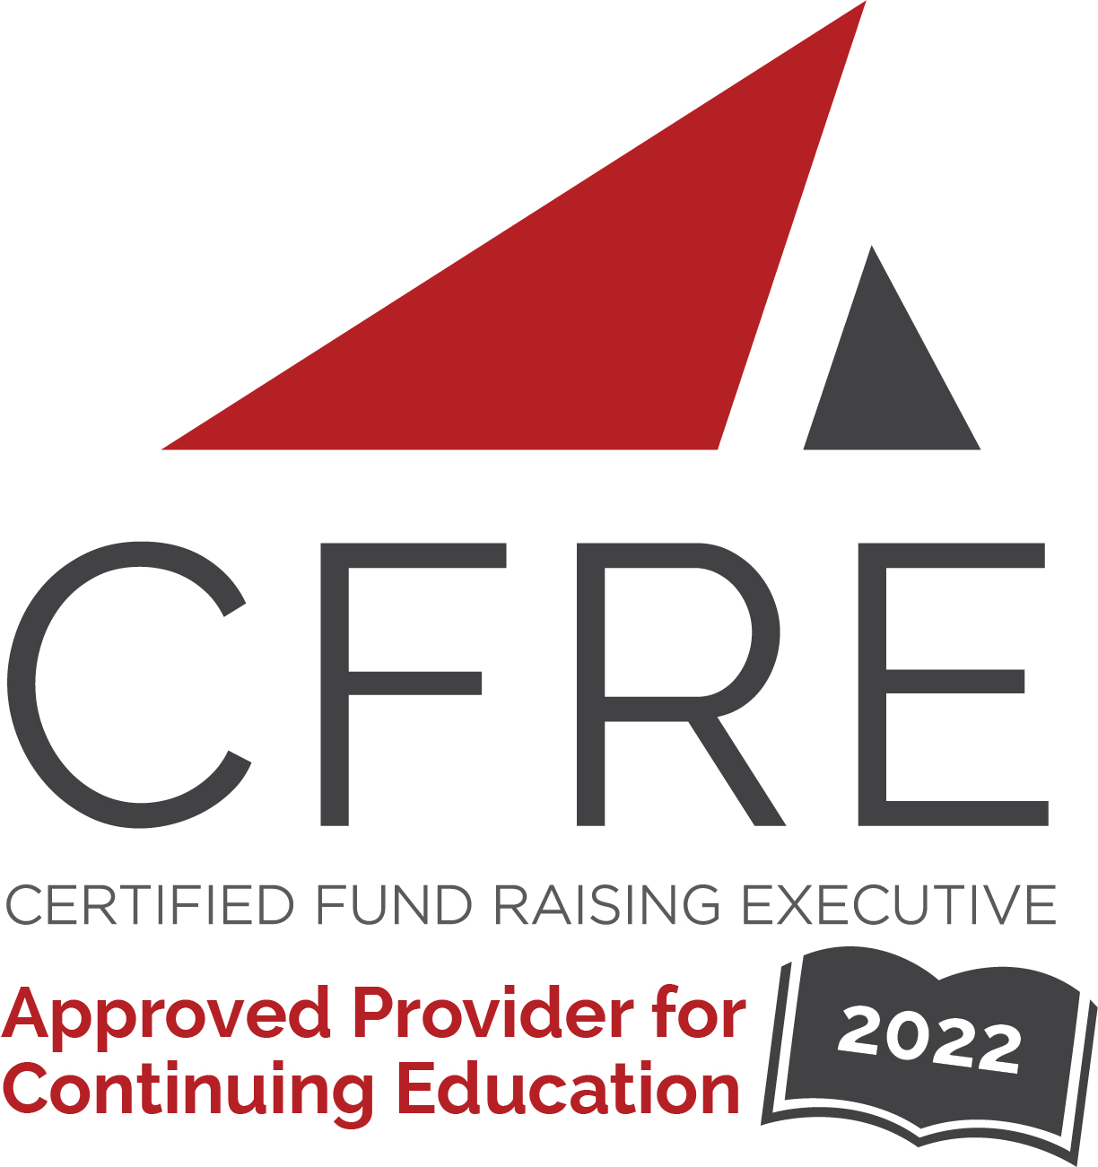  CFRE International has developed this form as a way for you to quickly track (and keep in your files!) the continuing education sessions you have attended. Simply check the boxes next to the sessions you attended. At the end of the conference, add up the total number of hours. Keep this sheet and you will be ready to complete your application form. All of the session slots listed are eligible for continuing education points on your CFRE application for initial certification and/or recertification. Sessions not listed here are not eligible for points. |  | CONTINUING EDUCATION POINTS TRACKER

Activity Organizer: - CASE
Title of Activity: - Annual Conference for Prospect Development
Names of Presenter(s): - Various
Dates and Location: - Nov 30 – Dec 2, 2022, New Orleans, LA

Date: Wednesday, November 30, 2022
Session 1: 1:15 [pm] – 2:30 [pm] (1.25 pts)
- [DEI and Data Governance]

Date: Wednesday, November 30, 2022
Session 2: 3:00 [pm] – 4:00 [pm] (1 pt)
- [It's Not Just the Numbers! - Income Psychology and Giving Behavior]
- [Developing Meaningful Reporting and Metrics]

Date: Wednesday, November 30, 2022
Session 3: 4:15 [pm] – 5:15 [pm] (1 pt)
- [Collaborating with Advancement Partners]

Date: Thursday, December 1, 2022
Session 1: 9:30 [am] – 10:30 [am] (1 pt)
- [Wealth Screening]

Date: Thursday, December 1, 2022
Session 2: 10:45 [am] – 11:45 [am] (1 pt)
- [Using Analytics to Drive Campaign Strategy]
- [Data Enrichment Methods for Prospect Research]

Date: Thursday, December 1, 2022
Session 3: 2:45 [pm] – 3:45 [pm] (1 pt)
- [Implementing and Evaluating Your Prospect Management Program]
- [Dashboard Creation With R]

Date: Thursday, December 1, 2022
Session 4: 4:00 [pm] – 5:00 [pm] (1 pt)
- [Don’t Excel, Pivot!: Data-Driven Wealth Analysis to Optimize your Pipeline]
- [Parents as Prospects]

Date: Friday, December 2, 2022
Session 1: 9:30 [am] – 10:30 [am] (1 pt)
- [The Joys and Challenges of Small Shops]
- [Portfolio Management & Moves Management]

Date: Friday, December 2, 2022
Session 2: 9:45 [am] – 12:00 [pm] (1.25 pts)
- [Advocating for Your Team]

Total number of points attained: __________

