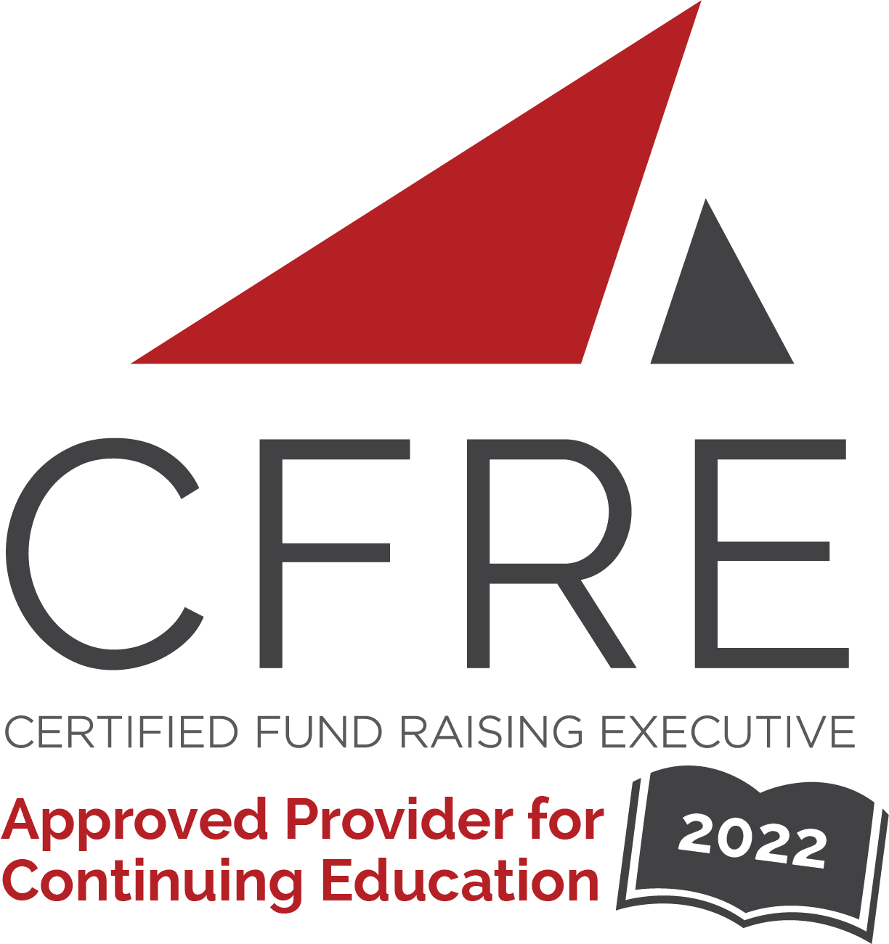  CFRE International has developed this form as a way for you to quickly track (and keep in your files!) the continuing education sessions you have attended. Simply check the boxes next to the sessions you attended. At the end of the conference, add up the total number of hours. Keep this sheet and you will be ready to complete your application form. All of the session slots listed are eligible for continuing education points on your CFRE application for initial certification and/or recertification. Sessions not listed here are not eligible for points. |  | CONTINUING EDUCATION POINTS TRACKER

Activity Organizer: - CASE
Title of Activity: - 2022 CASE Kentucky Conference
Names of Presenter(s): - Various
Dates and Location: - December 2, 2022, Lexington, KY

Date: Friday, December 2, 2022
Keynote: 9:45 [am] – 10:50 [am] (1 pt)
- [The Power of Storytelling: A Call to Consciousness]

Date: Friday, December 2, 2022
Session 1: 11:00 [am] – 11:50 [am] (1 pt)
- [The Cure for Imposter Syndrome]
- [Change is Hard: How to Embrace It and Move Your Team Forward]
- [Improve Your Team's Effectiveness by Leveraging Your Differences]
- [Dealing with Difficult Conversations]

Date: Friday, December 2, 2022
Session 2: 1:10 [pm] – 2:00 [pm] (1 pt)
- [Career Success: What path did you take? How would you advise others?]
- [Change is Hard: How to Embrace It and Move Your Team Forward]
- [Improve Your Team's Effectiveness by Leveraging Your Differences]
- [Dealing with Difficult Conversations ]

Date: Friday, December 2, 2022
Session 3: 2:10 [pm] – 3:00 [pm] (1 pt)
- [Go Further Together: Roundtable Discussion]

Date: Friday, December 2, 2022
Session 4: 3:10 [am/pm] – 4:00 [pm] (1 pt)
- [Luxury or Necessity? How Self-care and Wellness Lead to Better Performance] NFR

Total number of points attained: __________

